**Additional DataBases**

**External Training DataBase 1: Data Augmentation**

**Paper:** *A 12-lead electrocardiogram database for arrhythmia research covering more than 10,000 patients, JianweiZheng, JianmingZhang, Sidy Danioko, HaiYao, HangyuanGuo Cyril Rakovski*

**Raw description:**

|  |  |  |  |  |  |
| --- | --- | --- | --- | --- | --- |
| **Provenance** | **Number of Examples** | **Mean length of an example** | **Previous filtering (code availability)** | **Multi-Label** | **Sample Rate** |
| **China** | **10646** | **10s** | **Yes** | **Yes** | **500** |

**DataBase composition:**

|  |  |
| --- | --- |
| SB | 3836 |
| TAb | 1869 |
| SNR | 1826 |
| AF | 1754 |
| STach | 1532 |
| RBBB | 437 |
| AFL | 441 |
| LAD | 380 |
| PVC | 306 |
| PAC | 277 |
| IAVB | 246 |
| QAb | 233 |
| RAD | 221 |
| TInv | 157 |
| LBBB | 93 |
| LQT | 57 |
| LPR | 13 |
| LQRSV | 3 |

**Pathologies Co-occurences**

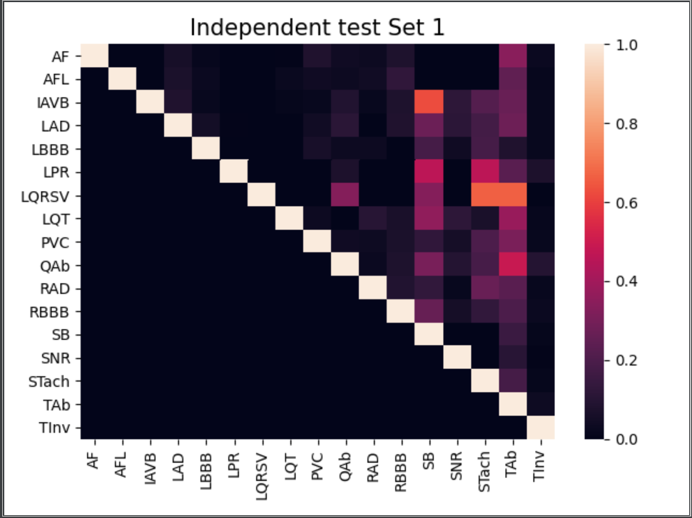

**External Training DataBase 2: Data Augmentation**

**Paper:** *A 12-Lead ECG database to identify origins of idiopathic ventricular arrhythmia containing 334 patients JianweiZheng, Guohua Fu, KyleAnderson, HuiminChu Cyril Rakovski*

**Raw description:**

|  |  |  |  |  |  |
| --- | --- | --- | --- | --- | --- |
| **Provenance** | **Number of Examples** | **Mean length of an example** | **Previous filtering (code availability if yes)** | **Multi-Label** | **Sample Rate** |
| **China** | **334** |  | **Yes/Yes** | **No** | **2000** |

**DataBase composition:**

|  |  |
| --- | --- |
| PVC | 325 |
| VT (Ventricular tachycardia) = ‘other’ | 9 |

**External Training DataBase 3: External Test Set**

**Paper:** *Lobachevsky University Electrocardiography Database*

**Raw description:**

|  |  |  |  |  |  |
| --- | --- | --- | --- | --- | --- |
| **Provenance** | **Number of Examples** | **Mean length of an example** | **Previous filtering (code availability if yes)** | **Multi-Label** | **Sample Rate** |
| **Russia** | **243** | **10s** | **No** | **No** | **500** |

**DataBase composition:**

|  |  |
| --- | --- |
| SNR | 143 |
| STach | 4 |
| SB | 25 |
| LAD | 66 |
| RAD | 3 |
| IAVB | 10 |
| IRBBB | 29 |
| RBBB | 4 |
| LBBB | 4 |
| NSIVCB | 4 |

**External Training DataBase 4: External Test Set**

**Paper:** *Automatic diagnosis of the 12-lead ECG using a deep neural network*

**Raw description:**

|  |  |  |  |  |  |
| --- | --- | --- | --- | --- | --- |
| **Provenance** | **Number of Examples** | **Mean length of an example** | **Previous filtering (code availability if yes)** | **Multi-Label** | **Sample Rate** |
| **Brazil** | **200** | **10s** | **No** | **No** | **300-600Hz** |

**DataBase composition:**

|  |  |
| --- | --- |
| IAVB | 28 |
| RBBB | 34 |
| LBBB | 30 |
| SB | 16 |
| AF | 13 |

**Summary Data Augmentation**

|  |  |
| --- | --- |
| SB | 3861 |
| TAb | 1869 |
| SNR | 1969 |
| AF | 1767 |
| STach | 1536 |
| RBBB | 475 |
| AFL | 441 |
| LAD | 446 |
| PVC | 631 |
| PAC | 277 |
| IAVB | 284 |
| QAb | 233 |
| RAD | 224 |
| TInv | 157 |
| LBBB | 123 |
| LQT | 57 |
| LPR | 13 |
| LQRSV | 3 |
| IRBBB | 29 |
| NSIVCB | 4 |